AI Engineering

# Machine Learning with Python

## Week 1 – Introduction to Machine Learning

Machine Learning Algorithms:

* Regression
  + Predict continuous values
* Classification
  + Predict the class/category of a case
* Clustering
  + Segmentation
* Associations
* Anomaly Detection
  + Discover exceptions
* Sequence Minning
  + Predict next events
* Dimension Reduction
  + PCA (reduction of variables)
* Recommendation Systems
  + Recommending items

Artificial Intelligence – Make computers intelligence to mimic human skills (computer vision, Language Processing, Creativity)

Machine Learning – Learns from previous problems to solve future ones (Classification, clustering, Neural Networks)

Deep Learning – Field of Machine Learning. Machines Learn, deeper than Machine Learning

Python Libraries:

* NumPy
  + a math library to work with N-dimensional arrays in Python
* SciPy
  + SciPy is a collection of numerical algorithms and domain specific toolboxes,
  + including signal processing, optimization,
  + statistics and much more.
  + SciPy is a good library for scientific and high performance computation.
* Matplotlib
  + 2D and 3D plotting
* Pandas
  + Provides easy to use data structures
* Scikit Learn
  + Machine Learning Library
  + Works with NumPy and SciPy
  + Easy to implement

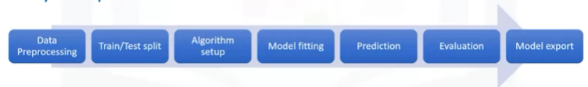

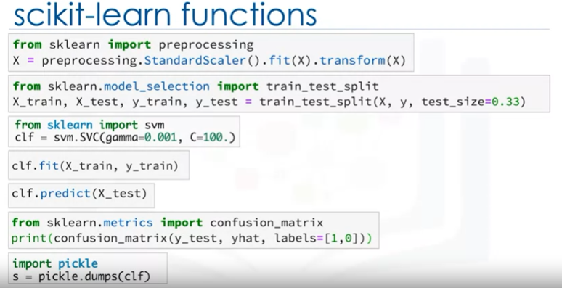

Supervised Learning

* Teaching model with labeled data
* Known Result

1. Regression
   1. Predicting continuous values
2. Classification
   1. Classifying data into categories

Unsupervised Learning

* Unknown Result
* Trains on unlabelled data

1. Clustering
   1. Group similar data for segmentation
2. Dimension Reduction (Feature Selection)
   1. Eliminated similar variables (distance in m and distance in km)
3. Market Basket Analysis
   1. If you buy Item A, you are more likely to buy Item B
4. Density Estimation

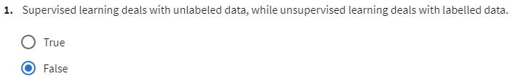

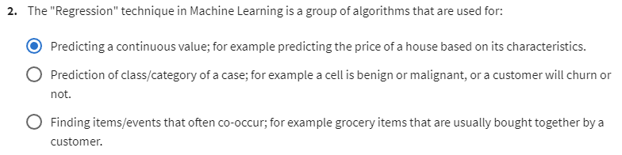

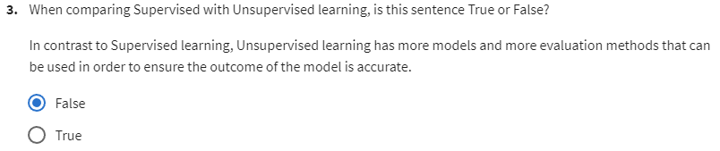

## Week 2 - Regression

Regression

* Simple Regression (1 variable)
  + Linear
  + Non-Linear
* Multiple Regression (>1 variable)
  + Linear
  + Non-Linear

Simple Linear Regression

* Very Fast
* No parameter tuning
* Easy to understand, highly interpretable

$\hat{y}$: Predicted value

$x_{1}$: Variable predictor

y : Actual value

$\overline{x}$: Mean variable predictor

$\overline{y}$: Mean actual value

n : Number of data points

$θ_{0}$: Bias coefficient

$θ_{1}$: Variable predictor coefficient

$$\hat{y}=θ_{0}+θ_{1}x_{1}$$

$$Residual Error=y-\hat{y}$$

$$Mean Square Error (MSE)=\frac{1}{n}\sum_{i=0}^{n}{{\left(y_{i}-\hat{y_{i}}\right)}^{2}}$$

Want to minimize the error (MSE)

$$θ_{1}=\frac{\sum_{i=1}^{n}{\left(x_{i}-\hat{x}\right)\left(y_{i}-\hat{y}\right)}}{\sum_{i=1}^{n}{{\left(x_{i}-\hat{x}\right)}^{2}}}$$

$$θ_{0}=\overline{y}-θ_{1}\overline{x}$$

Model Evaluation

1. Train and Test on same data set
   1. High Training Accuracy
   2. Low Out-of-Sample Accuracy
2. Train on 70% of data, test on remaining 30%
   1. Higher Out-of-Sample Accuracy
   2. Dependant on data used for training and testing

Training Accuracy

* Accuracy on the Training data set (overfit/underfit)

Out-of-Sample Accuracy

* Accuracy on future data

K-fold cross-validation

* + More accurate Accuracy

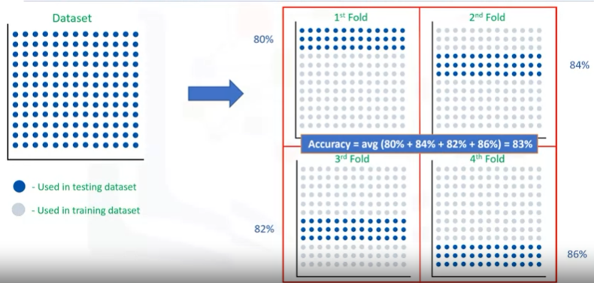

$$Mean Absolute Error (MAE)=\frac{1}{n}\sum_{j=0}^{n}{|y_{j}-\hat{y}|}$$

$$Mean Square Error (MSE)=\frac{1}{n}\sum_{j=0}^{n}{{\left(y_{j}-\hat{y_{j}}\right)}^{2}}$$

Exponentially increases error. Larger errors are more significant.

$$Root Mean Square Error (RMSE)=\sqrt{\frac{1}{n}\sum_{j=0}^{n}{{\left(y_{j}-\hat{y_{j}}\right)}^{2}}}$$

$$Relative Absolute Error (RAE)=\frac{\sum_{j=1}^{n}{|y_{j}-\hat{y}|}}{\sum_{j=1}^{n}{|y_{j}-\overline{y}|}}$$

$$Relative Square Error (RSE)=\frac{\sum_{j=1}^{n}{{\left(y_{j}-\hat{y_{j}}\right)}^{2}}}{\sum_{j=1}^{n}{{\left(y_{j}-\overline{y}\right)}^{2}}}$$

$$R^{2}=1-RSE$$

Higher R2, the more accurate the model.

Multiple Linear Regression

$θ^{T}$: The parameters (nx1)

X : Feature set (1xn)

$$\hat{y}=θ_{0}x_{0}+θ_{1}x_{1}+θ_{2}x_{2}+{…+θ}_{n}x_{n} x_{0}=1$$

$$\hat{y}=θ^{T}X$$

Estimating

* + Ordinary Least Squares
    - Linear algebra operations
    - <10k data
  + Gradient Descent
    - >10k data

Can use dummy variables for discrete variables.

Polynomial Regression

$$\hat{y}=θ_{0}x_{0}+θ_{1}x_{1}^{2}+θ_{2}x_{2}^{1/2}+{…+θ}_{n}x_{n} x_{0}=1$$

Non-Linear Regression

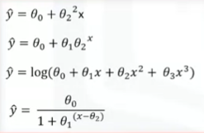

Q&A

1. Is it Linear or Non-linear?
   1. Inspect Visually
   2. Accuracy

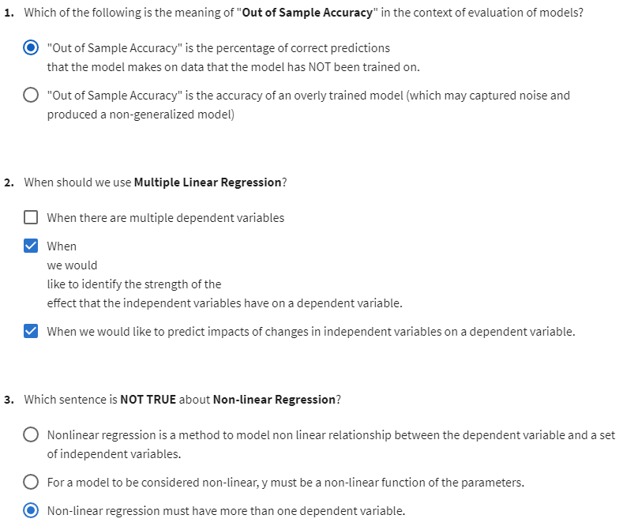

## Week 3 – Classification

Classification

* Discrete outputs
* Categories or Classes

Algorithms

* Decision Trees (ID3, C4.5, C5.0)
* Naïve Bayes
* Linear Discriminant Analysis
* K-Means
* Logistic Regression
* Neural Networks
* Support Vector Machines (SVM)

K-Nearest Neighbor

K = 1

Class is the same as the nearest 1 data point

K = 5

Class is the same as the majority of the 5 nearest data points

1. Pick a value for K
2. Calculate distance of all data points to new point
3. Select the K nearest points
4. Predict Class using majority

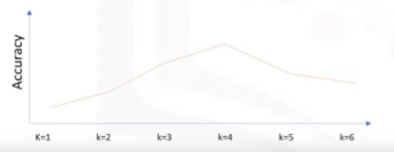

Evaluation Metrics

1. Jaccard Index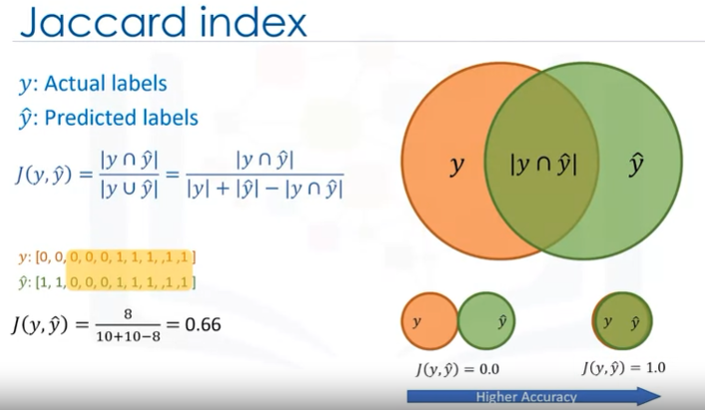
2. F1 Score

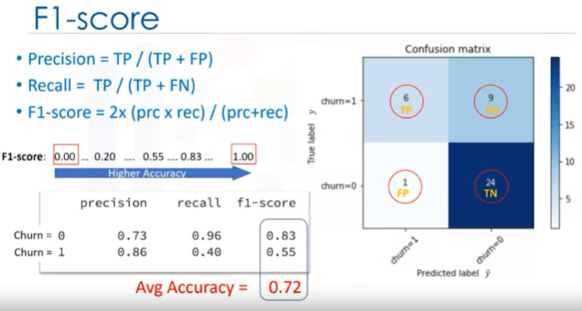

1. Log Loss

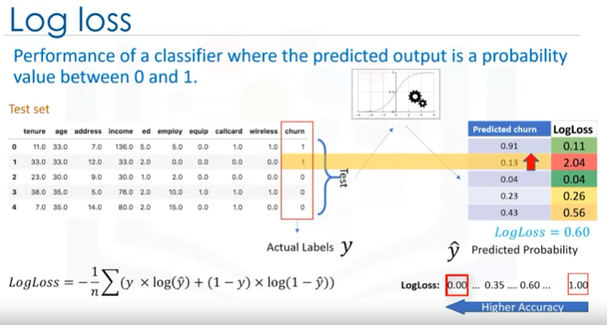

Decision Trees

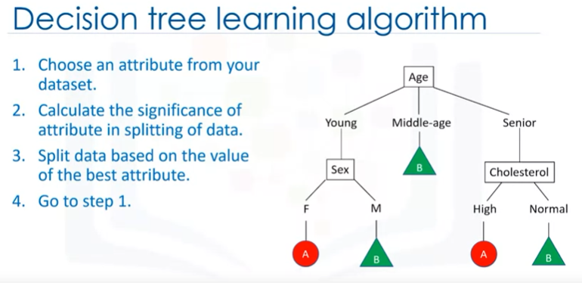

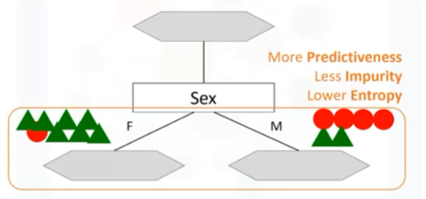

* Pure = 100%
* Uses Recursive partitioning to minimize impurity
* Entropy – Measure of randomness/uncertainty in the data
  + Highest Entropy = 1 (5A – 5B)
  + Lowest Entropy = 0 (10A – 0B)
* Chose the variable that results in the highest information gain
  + Information gain – Increases the level of certainty after splitting

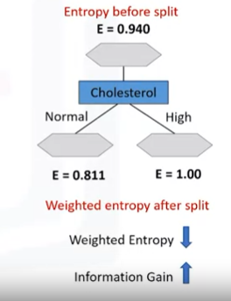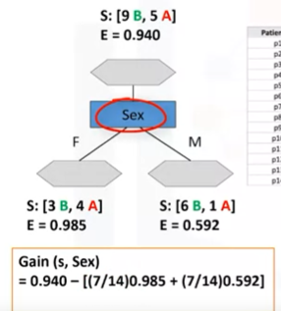

Logistic Regression

* Linear Regression but for categories or binary
* Returns a probability
* Decision boundary can be polynomial and complex

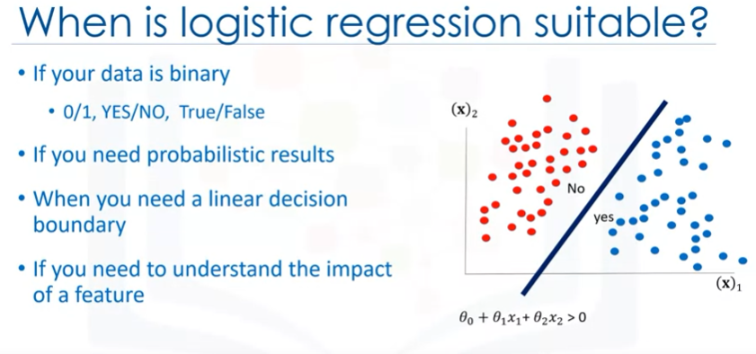

Linear vs Logistic Regression

* Linear’s result
  + Produces a number
  + Can’t distinguish difference between data points and how well they belong to the category
* Logistic
  + Produces a probability

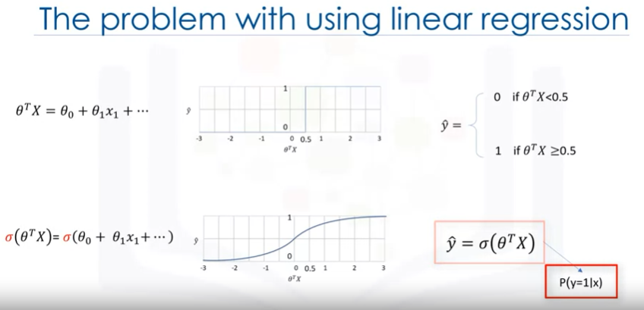

Logistic Regression

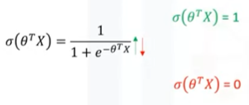

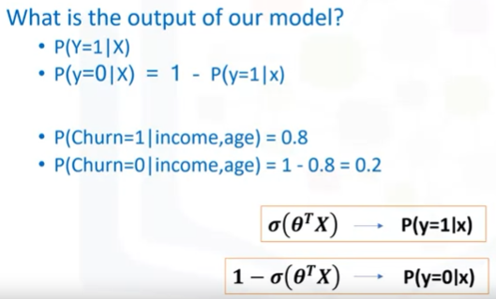

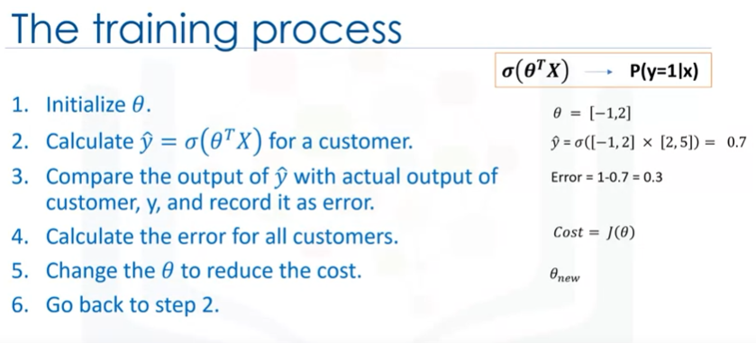

*** Normalization and mean normalization

Logistic Regression Training

* Want to minimize the cost function
  + Change the weight of the parameters

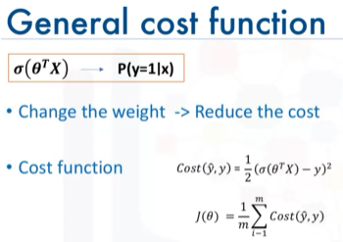

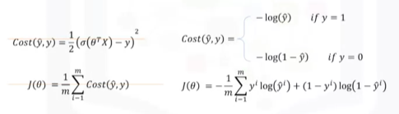

* Minimize cost function using Gradient Descent

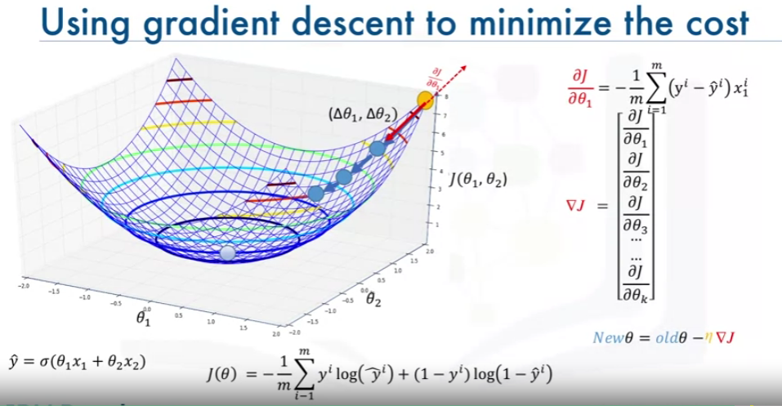

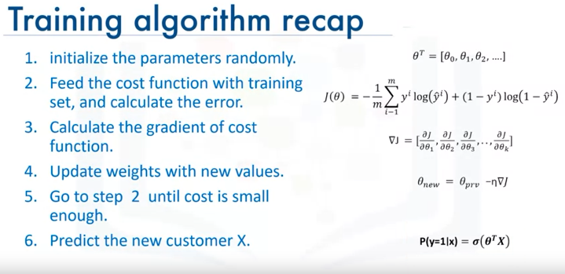

SVM

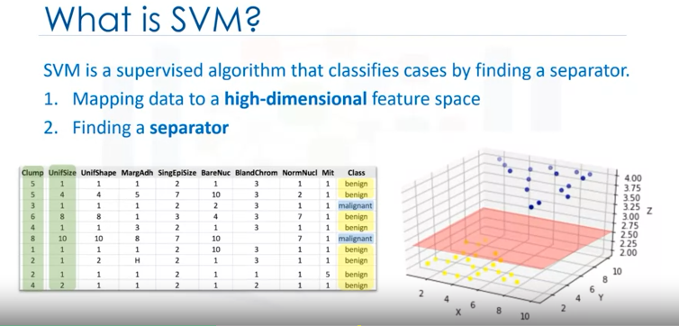

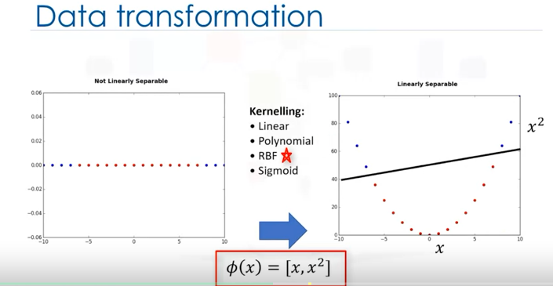

* Use Kernelling to find a hyperplane for the data
  + Makes the data linearly separable

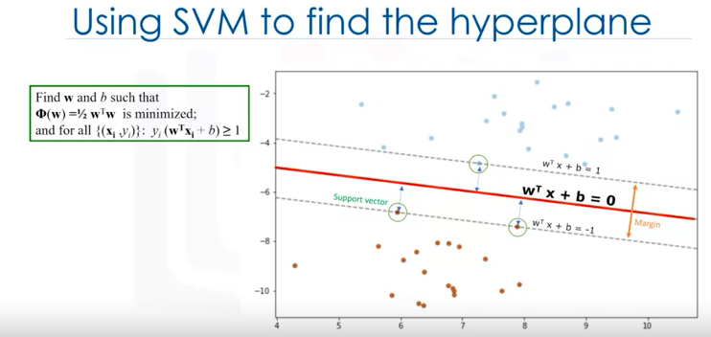

* Pros and Cons
  + Pros
    - Accurate in high dimensional spaces
    - Memory efficient
      * Relies on the support vectors from the training set alone for calculations and ignores the others
  + Cons
    - Prone to over fitting if (# features >> # Samples)
    - No probability
    - Use for <1000 data points
* Great for
  + Image recognition
  + Text category
  + Detecting Spam
  + Sentiment Analysis
  + Gene classification
  + Regression, outlier detection, clustering

## Week 4 – Clustering

* Customer segmentation

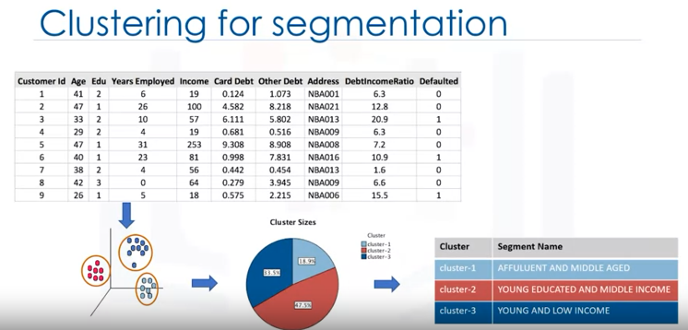

Use

* Exploratory Data Analysis
* Summary Generation
* Outlier detection
* Finding Duplicates
* Pre-processing step

Hierarchical – small size

Partitioned-based – mid-large size

Density-based – Lots of noise

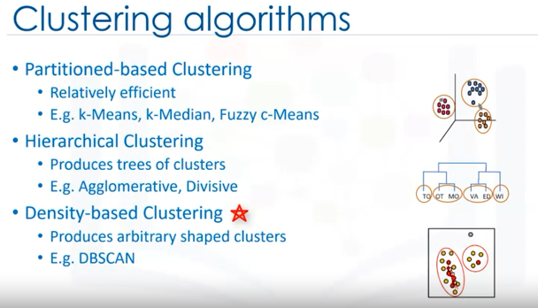

k-Means

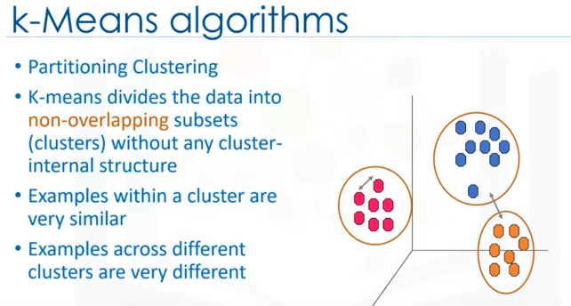

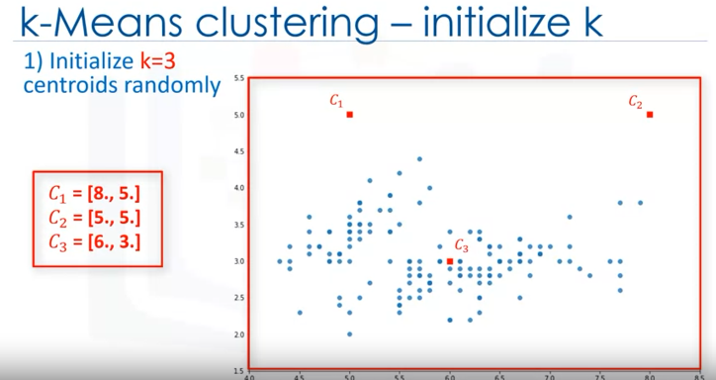

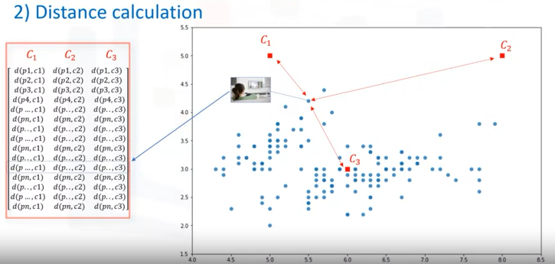

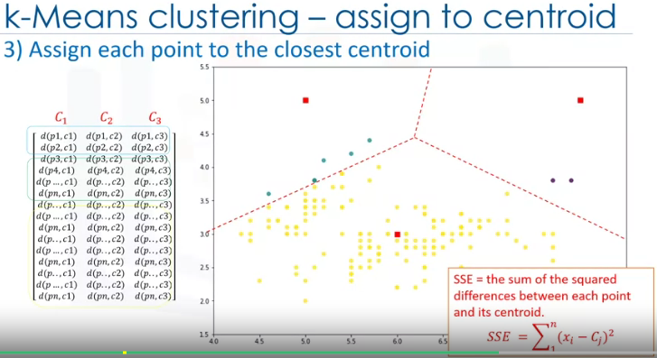

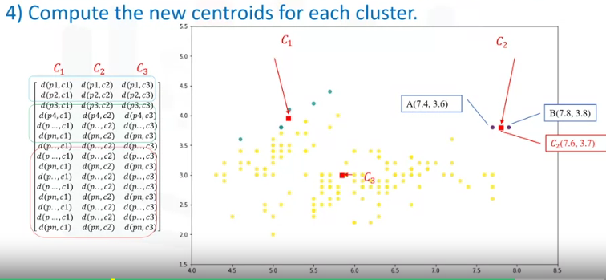

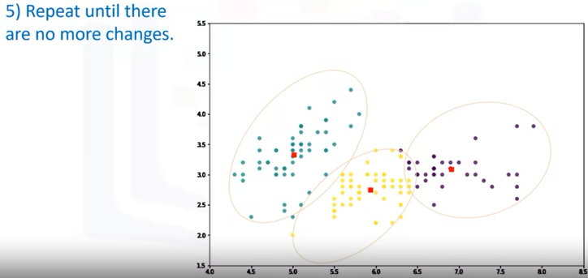

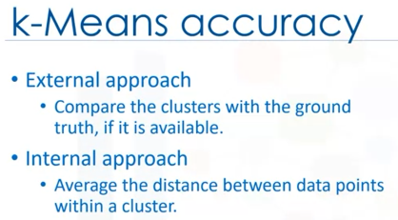

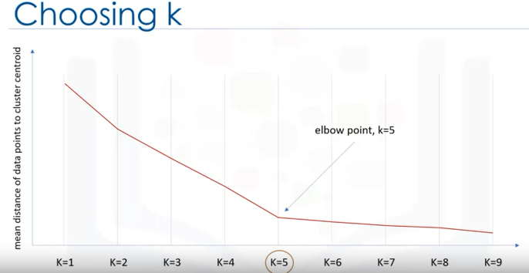

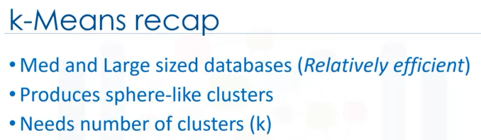

Hierarchical

* Divisive
  + Top Down
* Agglomerative (popular)
  + Down Top

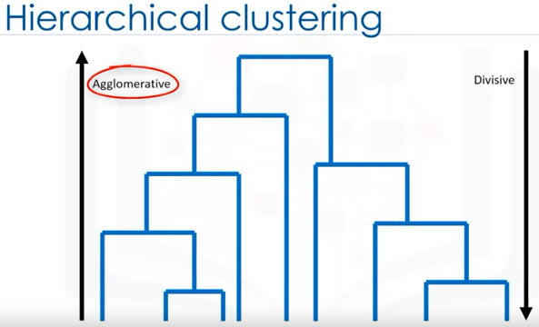

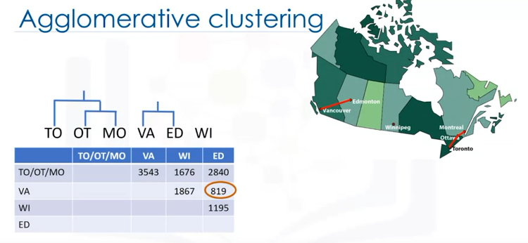

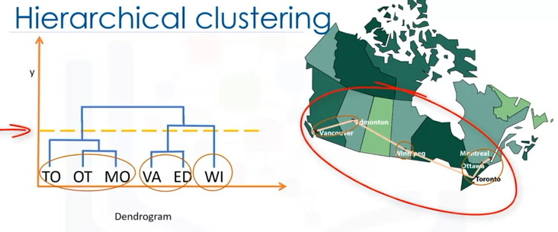

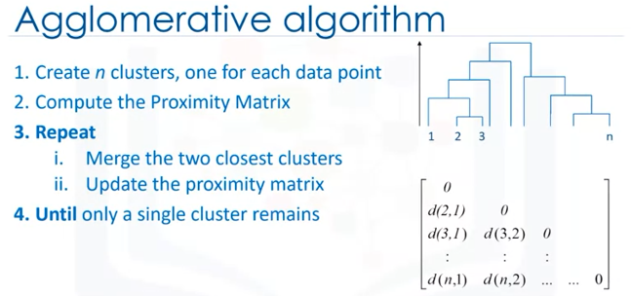

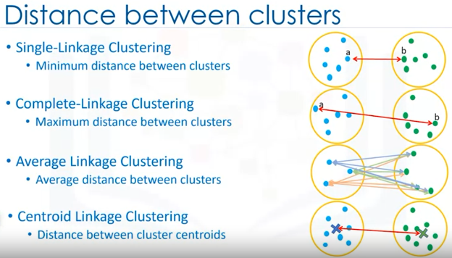

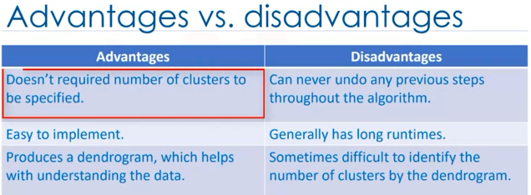

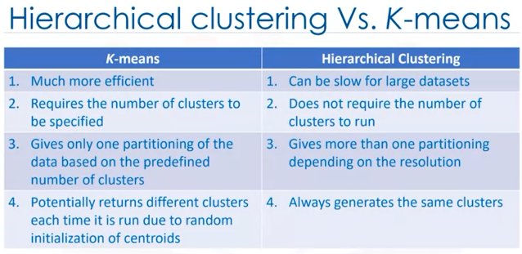

DBSCAN (Density-Based Spatial Clustering of Applications with Noise)

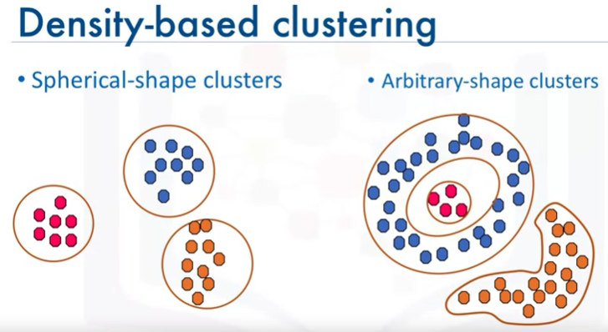

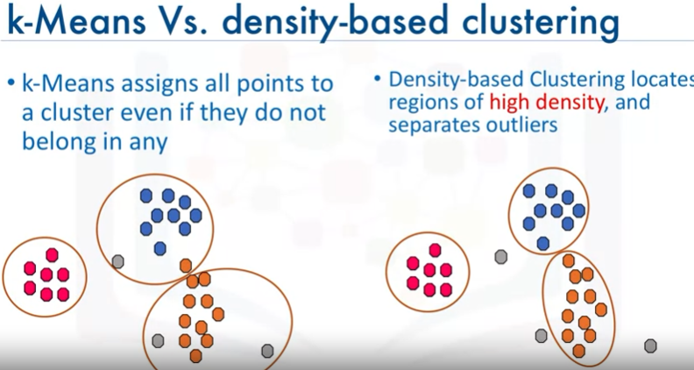

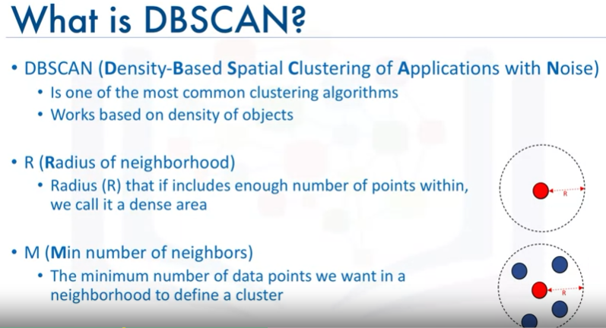

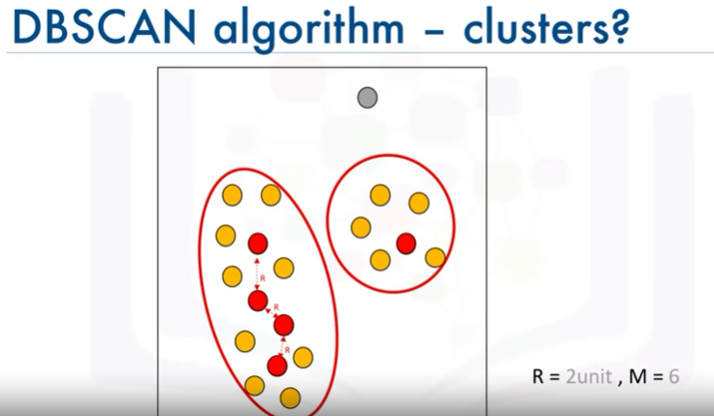

* Red – Core Point (6 points in R)
* Yellow – Border Point (<6 points in R, Core Point in R)
* Grey - Outlier

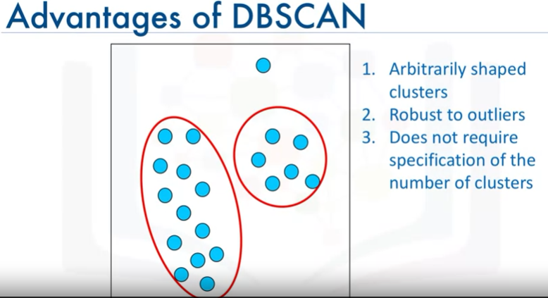

## Week 5 – Recommender Systems

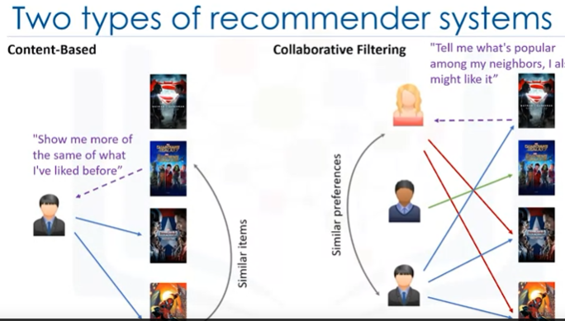

*Also hybrid of the two (Hybrid)

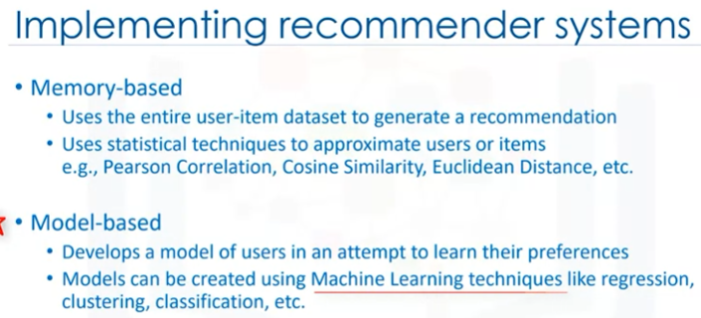

Content Based

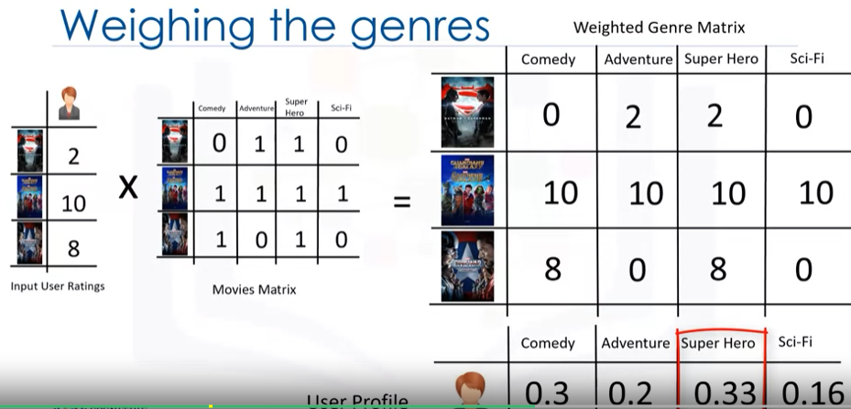

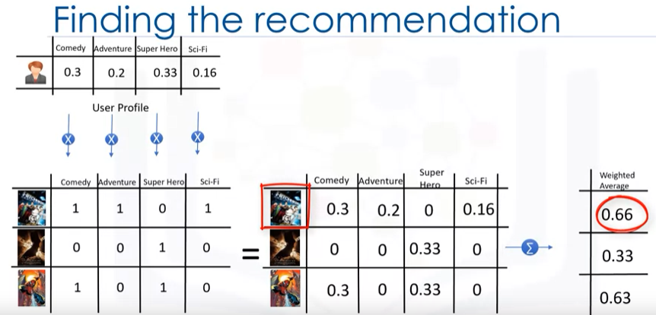

Collaborative

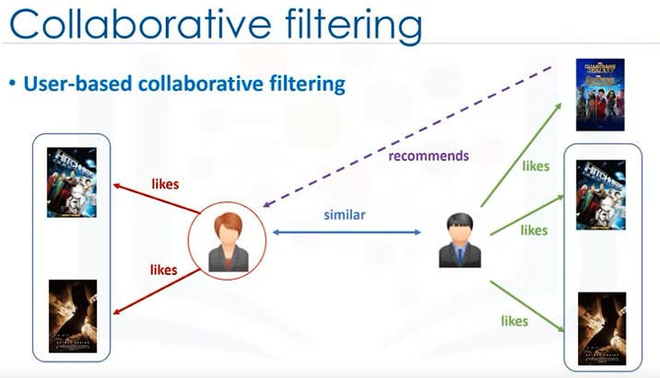

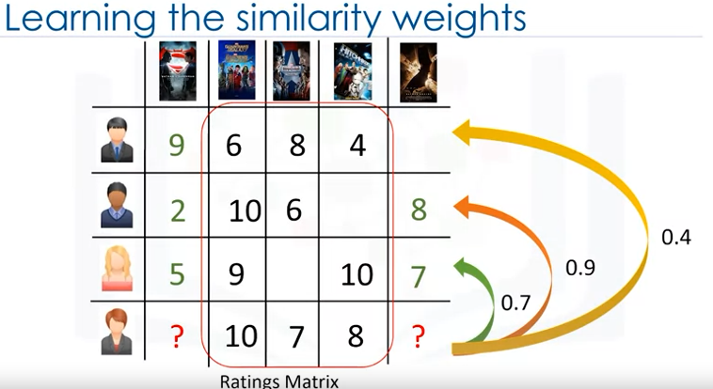

Learn similarity using the distances

* Jaccard distance
* Cosine Distance

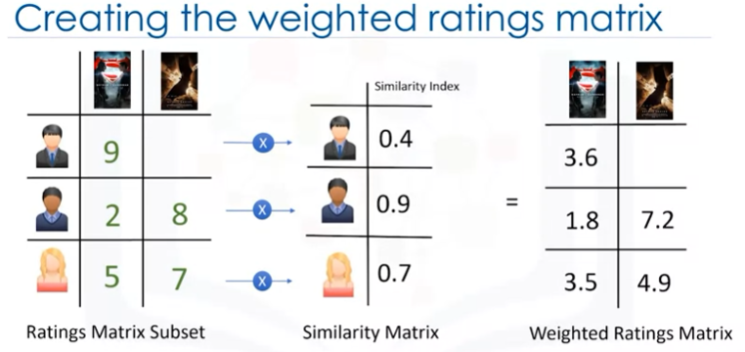

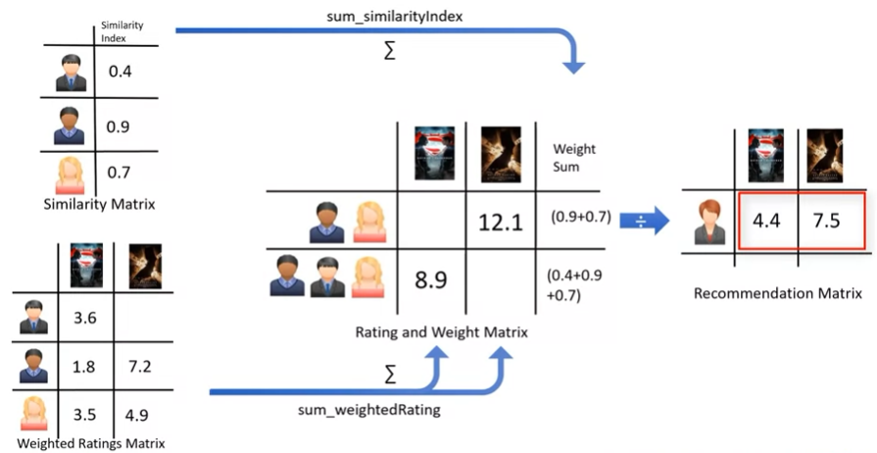

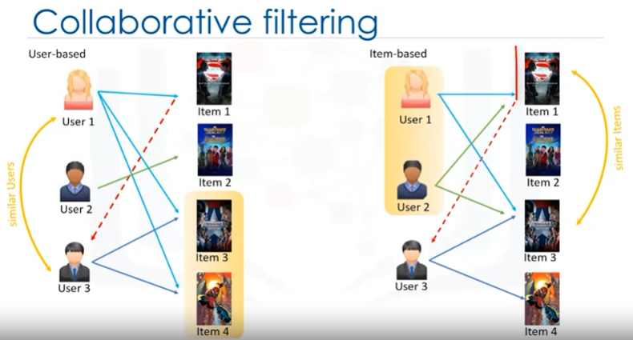

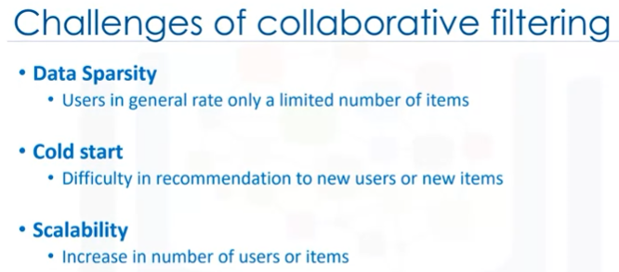

# Introduction to Deep Learning & Neural Networks

## **Module 1 - Introduction to Deep Learning**

* Introduction to Deep Learning
* Biological Neural Networks
* Artificial Neural Networks - Forward Propagation

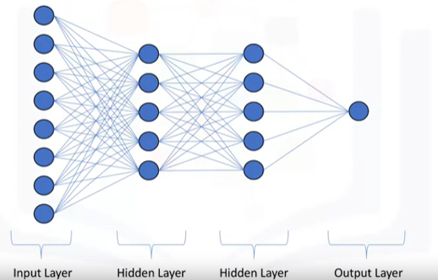

* Forward Propagation
  + Input to Output

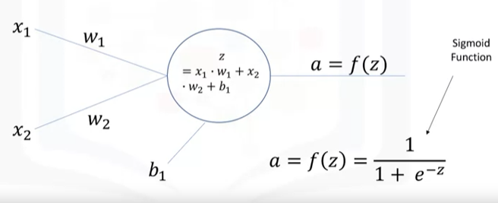

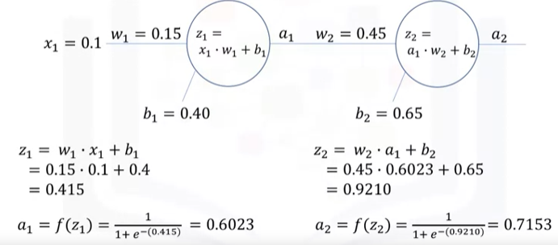

* Backpropagation
* Activation Functions

## **Module 2 - Artificial Neural Networks**

* Gradient Descent
* Backpropagation
* Vanishing Gradient
* Activation Functions

## **Module 3 - Deep Learning Libraries**

* Introduction to Deep Learning Libraries
* Regression Models with Keras
* Classification Models with Keras

## **Module 4 - Deep Learning Models**

* Shallow and Deep Neural Networks
* Convolutional Neural Networks
* Recurrent Neural Networks
* Autoencoders

## **Module 5 - Course Assignment**

# Introduction to Computer Vision and Image Processing

# Deep Neural Networks with PyTorch

# Building Deep Learning Models with TensorFlow

# AI Capstone Project with Deep Learning